2010 H1 Preliminary Examination

Paper 1: MCQ

1 | C | 11 | B | 21 | A
2 | D | 12 | A | 22 | A
3 | B | 13 | A | 23 | B
4 | B | 14 | D | 24 | B
5 | C | 15 | B | 25 | C
6 | A | 16 | D | 26 | D
7 | B | 17 | C | 27 | B
8 | D | 18 | A | 28 | C
9 | A | 19 | C | 29 | D
10 | C | 20 | C | 30 | B

Paper 2

Section A
Answer all the questions in this section in the spaces provided.

1 | Aluminium can exists as two isotopes, ²⁶Al and ²⁷Al.
 | (a) | (i) | With the aid of the Data Booklet, write down the quantity of the following sub-atomic particles of the isotope ²⁶Al and ²⁷Al.
 |  |  |  | ²⁶Al | ²⁷Al
 |  |  | Protons: | 13 | 13
 |  |  | Neutrons: | 15 | 14
 |  |  | Electrons: | 13 | 13
 |  | (ii) | Define the term isotopes.
 |  |  | Isotopes are element with the same atomic number (number of protons) but different mass number (due to different number of neutrons).
 |  | (iii) | Given that the relative atomic mass of Al is 26.8. Calculate the relative abundance of both isotopes.  Let the relative abundance of ²⁶Al be x, the relative abundance of ²⁷Al be (100-x)  26x + 27(100-x) / 100 = 26.8  x = 20%  The relative abundance of ²⁶Al is 20%, the relative abundance of ²⁷Al is 80%
 |  |  | [5]

 | (b) | Aluminium reacts with chloride to form aluminium chloride, AlCl₃. In the vapour state, the apparent molecular mass of aluminium chloride is 267.  In the solid state, aluminium chloride is a non-conductor of electricity. When dissolve in water, aluminium chloride is found to be able to conduct electricity.
 |  | (i) | Draw a dot-and-cross diagram of aluminium chloride in the vapour state.  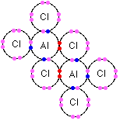
 |  | (ii) | Explain in terms of structure and bonding, why solid aluminium chloride does not conduct electricity.
 |  |  | Simple covalent molecule/simple molecular structure with covalent bonds, no free electrons or ions to conduct electricity.
 |  | (iii) | Explain, with the aid of an equation, why aluminium chloride is able to conduct electricity in water.
AlCl₃ dissolves in water and undergoes partial hydrolysis to give a weakly acidic solution (pH = 4 which contains ions to act as charge carriers to conduct electricity. (1m)

AlCl₃ (s) + aq ➔ [Al (H₂O)₆]³⁺ (aq) + 3Cl– (aq)

[Al(H₂O)₆]³⁺ (aq) ➔ [Al(H₂O)₅(OH)]²⁺ (aq) + H⁺ (aq)

 |  |  | [6]
 |  |  | [Total: 11]

2 | (a) | After consuming food the pH in mouth can drop from pH 6.8 to a pH of about 4.8 as the sugar is broken down to lactic acid. In time, the hydrogen carbonate ions (HCO₃⁻) in saliva restore the pH to its original value.
 |  | (i) |  | Calculate the H⁺ concentration in the mouth at pH 6.8  [H⁺] = 10^{-6.8} =1.58 x 10⁻⁷ mol dm⁻³
 |  | (ii) | Write an ionic equation to show how hydrogen carbonate ions restore the pH to its original value.
 |  |  | HCO₃⁻ + H⁺→ H₂O + CO₂
 |  |  |  |  |  | [2]
 | (b) | Ammonia is manufactured in the Haber process according to the equation: N₂ (g) + 3 H₂ (g) ⇔ 2 NH₃ (g) (ΔH = -92.4 kJ mol⁻¹)
 |  | (i) | State the typical conditions used in the Haber process and explain how the yield is affected using Le Chatelier’s Principle.
 |  |  | Temperature: |  | 500°C
 |  |  | Reasons: Le Chaterlier’s principle predicts that low temperature gives higher yield as the forward reaction is exothermic, low temperature will cause equilibrium shift right to produce more heat.
 |  |  | Pressure: |  | 200 atm
 |  |  | Reasons: Le Chaterlier’s principle predicts that high pressure gives higher yield as the equilibrium shift right to reduce no of moles of gaseous molecules/particles.
 |  |  |  |  |  | [4]

 | (c)  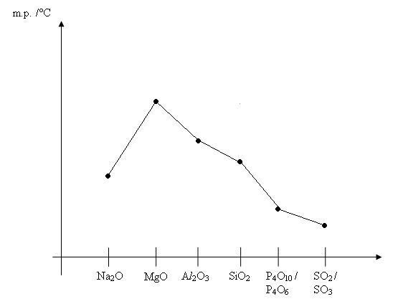 | (i) | In the space provided below, sketch a graph of the melting point of oxides of elements from sodium to sulphur.
 |  | (ii) | Explain as fully as you can why the melting point varies in the way shown.
- Oxides of Na, Mg and Al are ionic, hence they have high melting and boiling points. Increasing melting points of the oxides are due to increasing lattice energies of the compounds.
- SiO₂ has a giant molecular structure. Numerous strong Si—O covalent bonds must be broken before melting occurs. Hence it has high melting and boiling points as well.
- Oxides of P and S have simple molecular structures with weak VDW interactions between the discreet molecules which need to be overcome before melting occurs. Hence they have low melting points.
 |  |  |  | [5]
 |  | [Total: 11]

3 | (a) | Compound A is a sweet smelling compound with molecular formula C₉H₁₀O₂. Heating of A with dilute sulfuric acid produces B, C₇H₆O₂ and C which gives out steamy white fumes when reacted with a anhydrous PCl₅ to give compound D. Compound B and C reacts with Na, but only B reacts with NaOH.
Suggest a possible structure for each of the compounds A to D.

A  Ethyl benzoate  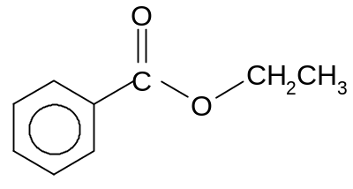 | B  Benzoic acid  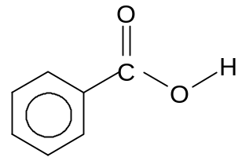
C  Ethanol  CH₃CH₂OH | D  Chloroethane  CH₃CH₂Cl
 |  |  |  | [4]

 | (b) | The reaction scheme below represents reactions of organic compounds.  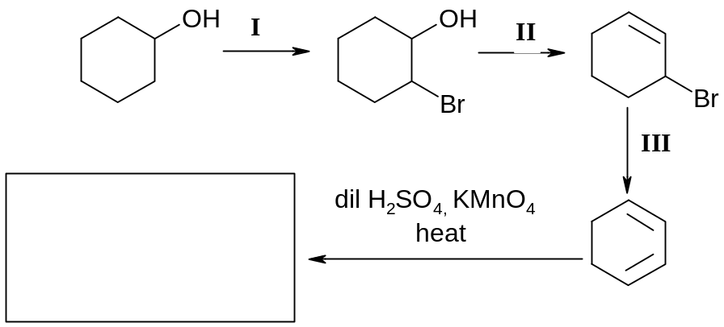  IV
 |  | (i) | What are the reagents and conditions used in Steps I, II and III?
  Step | Reagents | Conditions
  I | Br₂ | UV
  II | Conc H₂SO₄ | 170°C
  III | Ethanolic KOH | heat
 |  | (ii) | Give the structural formulae of product formed in step IV.  Structure of butanedioic acid or carbon dioxide
 |  |  |  | [4]
 |  | [Total: 8]

4 | Our bodies get energy by the digestion and metabolism of food. A combustion reaction occurs in our bodies when glucose, C₆H₁₂O₆ is burned in the presence of oxygen, carbon dioxide, water, and heat is produced. The energy released in the combustion of food molecules is converted into heat energy (to maintain our constant body temperature), mechanical energy (to move our muscles), and electrical energy (for nerve transmission). The total amount of energy released by the digestion and metabolism of food is called its calorie content.  The amount of energy in food can be measured by burning the food in a calorimeter. The temperature change produced as the water heated, the specific heat of water (4.184 J/gK) or 1 calorie/gK ), and the mass of the water being heated are used to determine the amount of calories in the food.  A nutritional Calorie (Cal) is equivalent to one energy kilocalorie (kcal) or  1000 calories (cal).  A student wanted to determine the amount of calories in corn puffs by performing a calorimetric experiment as shown:  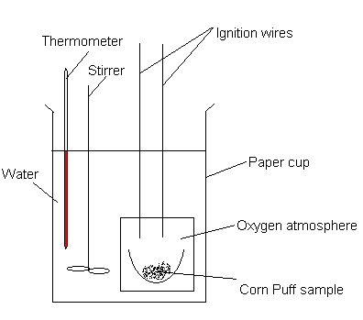  50 cm³ of water was added to the calorimeter and 0.35 g of food corn puffs combusted. A temperature rise of 20 °C was recorded.

 | (a) | (i) | Calculate the calories absorbed by the water.
calories absorbed by water = mc∆T
= 50 x 1 x 20
=1000 cal

 |  | (ii) | Calculate the heat released by burning the corn puff.  heat released = 1000 x 4.184 = 4184 J
 |  | (iii) | Calculate the calories per gram of corn puff.  calories per gram of food = 1000 / 0.35  = 2857 cal
 |  | (iv) | Convert calories per gram of food to nutritional Calories/ gram of food (Cal/g).  1 nutritional Calories = 1000 calories  2857 calories = 2.86 nutritional Calories/g
 |  | (v) | According to the nutritional information of the package of corn puff, how does the nutritional Calories (Cal) compare with the student’s experimental data?
 |  |  | The nutritional information on the packaging will be higher than the experimental one as in the experiment, heat is loss during burning of food, resulting in less heat being absorb by the water and lower cal calculated.

 |  | (vi) | List one possible source of error in this experiment and suggest how to overcome the error.
 |  |  | Heat loss. Insulate the calorimeter/lag the calorimeter
 |  |  |  | [7]

 | (b) | The structure of glucose is  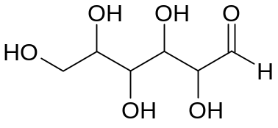
 |  | (i) | Identify the functional groups present in glucose.
 |  |  | alcohol and aldehyde
 |  | (ii) | The presence of glucose can be determined by simple chemical test based on the functional groups present. Give a simple chemical test and observation expected.
 |  |  | Test: | Tollen’s reagent, warm
 |  |  | Observations: | silver mirror
 |  | Other tests includes 2,4-DNPH, Na, Fehling’s solution, KMnO₄
 |  | [3]
 |  | [Total: 10]

Section B
Answer two of the three questions in this section on separate paper.

5 | (a) | Hydrogen peroxide decomposes according to the equation below:  2H₂O₂(aq) → 2H₂O(l) + O₂(g)  Hydrogen peroxide can also be oxidised to oxygen by potassium manganate(VII).
5 | (a) | (i) | What is the oxidation state of oxygen in hydrogen peroxide?  -1
 |  | (ii) | What volume of acidified potassium manganate(VII) of concentration 0.0200 mol dm⁻³ is decolourised by 50 cm³ of hydrogen peroxide of concentration 0.0100 mol dm⁻³?  Number of mol of H₂O₂ = 0.01 x 50 x 10⁻³ = 5 x 10⁻⁴ mol  Number of mol of MnO4⁻ = 5 x 10⁻⁴ x (2/5) = 2 x 10⁻⁴ mol  Volume of MnO4⁻ = 2 x 10⁻⁴ ÷ 0.02 = 0.01 dm³ = 10 cm³
 |  | (iii) | What volume of oxygen is evolved at room temperature and pressure in this titration?  Number of mol of O₂ = Number of mol of H₂O₂ = 5 x 10⁻⁴ mol  Volume of O₂ at r.t.p. = 5 x 10⁻⁴ x 24 = 0.0120 dm³ or 12 cm³ | [5]

 | (b) | The sketch below shows the first five ionisation energy for phosphorus.  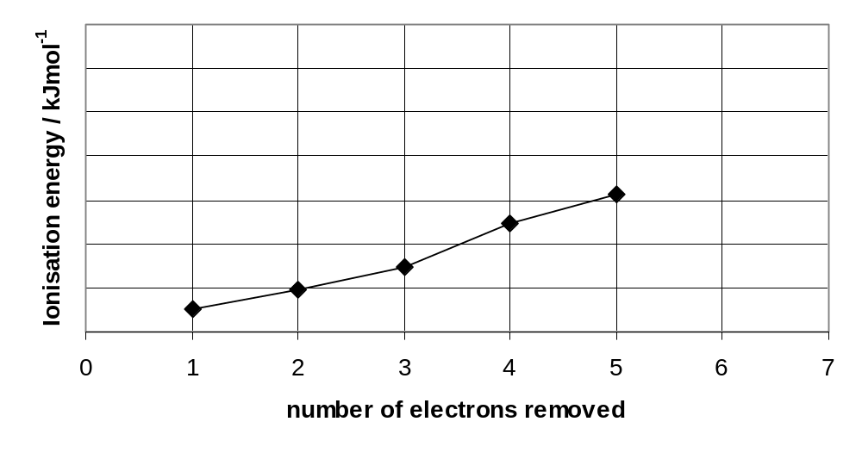
 |  | (i) | Write the electronic configuration of phosphorus in the ground state.  1s² 2s² 2p⁶ 3s² 3p³
 |  | (ii) | Write an equation to represent the second ionisation of phosphorus.  P⁺ (g) → P²⁺ (g) + e⁻
 |  | (iii) | On the sketch above, draw an “X” to indicate a value for the 6th ionisation energy of phosphorus.  X

 |  | (iv) | Explain briefly why the fourth ionisation energy of phosphorus is higher than expected compared to the third ionisation energy.  The third e removed is a 3p e and the fourth e removed is a 3s e.  Hence the fourth e, being at a lower energy level, requires more energy for removal (slight increase in IE to be associated with subshell). | [5]
 | (c) | (i) | Draw dot and cross diagrams of NO and ClO₂ and state the shape of ClO₂ drawn.  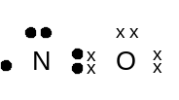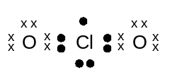  ClO₂: bent/v-shape
 |  | (ii) | The boiling points of chlorine dioxide and chlorine are 11ºC and  –34ºC respectively. Explain the difference.  Cl₂ has instantaneous dipole – induced dipole forces of attraction between molecules.  ClO₂ has permanent dipole – permanent dipole forces of attraction between molecules.  Hence greater energy is required to overcome the stronger permanent dipole – permanent dipole forces of attraction in ClO₂ and hence it’s higher melting point. | [6]

 | (d) | The melting points of magnesium chloride and silicon tetrachloride are as follows:
  compound | melting point / ºC
  MgCl₂ | 714
  SiCl₄ | −70
 |  | (i) | Briefly relate these melting points to the structure and bonding in each of these oxides.  MgCl₂ has a giant ionic structure.  A lot of energy is required to overcome the strong electrostatic forces of attraction between the oppositely charged ions.  SiCl₄ has a simple molecular structure.  It has discrete molecules held together by weak van der Waals’ forces. Less energy is required to break these bonds.  Hence, SO₃ has a very low melting point.
 |  | (ii) | The lattice energy of sodium oxide is – 2000 kJ mol⁻¹.  Explain how you would expect the numerical magnitude of the lattice energy of sodium sulphide, Na₂S, to compare with that of sodium oxide, Na₂O.  ⎢Lattice energy ⎢ ∝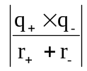  Ionic radius of S²⁻ is greater than that of O²⁻  Therefore, lattice energy of Na₂S is smaller than that of Na₂O  or lattice energy of Na₂O is greater than that of Na₂S. | [4]
 |  |  | [Total: 20]

6 | Hydrogen sulfide is produced when thioacetamide undergoes acidic hydrolysis. The reaction is as shown:  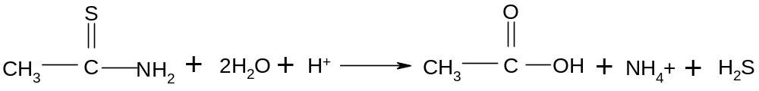
 | (a) | A series of experiments were carried out to investigate the kinetics of the reaction. The following results were obtained.  Use the data given in the table above to find the
  Experiment | Initial concentration of reactant |  | Initial rate of formation of H₂S  mol dm⁻³ s⁻¹
  Experiment | Thioacetamide,  mol dm⁻³ | H⁺,  mol dm⁻³ | Initial rate of formation of H₂S  mol dm⁻³ s⁻¹
  1 | 0.240 | 0.480 | 8.0
  2 | 0.240 | 0.120 | 2.0
  3 | 0.360 | 0.240 | 9.0
  4 | 0.120 | 0.120 | 0.5
  5 | 0.240 | 0.060 | 1.0
  6 | 0.014 | 1.350 | a
 | (a) | (i) | rate equation  Compare expt 1 and 2, [H⁺] decrease by 4, rate decrease by 4, order w.r.t H⁺ is 1.  Compare expt 2 and 4, [Thioacetamide] halved, rate decrease by 4, order w.r.t Thioacetamide is 2.  Rate = k[Thioacetamide]² [H⁺]
 |  | (ii) | rate constant, stating its units  using expt 1, k = 8/(0.240)² x (0.480)  = 289.4 mol⁻² dm⁶ s⁻¹
 |  | (iii) | value of initial rate, a for experiment 6.  a = 0.0766 mol dm⁻³ s⁻¹ | [6]
 | (b) | Using collision theory, explain the effect of adding water on the rate and rate constant of the reaction in (a).  Adding water lowers the concentration both reactants (less no of moles of particles per unit volume). No of effective collision decrease, rate decreases. Since there are no change to temperature, rate constant remains unchanged/constant. |  | [3]
 | (c) | With the aid of a suitable diagram, explain why an increase in temperature causes an increase in rate of formation of H₂S.  Blotzmann  Increase temperature results increase in particles with energy greater than or equal to activation energy. Thus no of effective collision increased rate of reaction increased. |  | [3]

 | (d) | One use of hydrogen sulfide is to produce sulfur and sulfur dioxide. The latter dissolves in water readily to form an acidic solution.
 |  | (i) | Write an equation for sulfur dioxide in water.  SO₂ + H₂O → H₂SO₃
 |  | (ii) | Given that the concentration of H⁺ ion is 3.98 x 10⁻³ mol dm⁻³, calculate the pH of the acidic solution.  pH = - log ₁₀ 3.98 x 10⁻³ = 2.4
 |  |  |  |  | [2]
 | (e) | One of the side products of this reaction is ethanoic acid. When equal amounts of sodium ethanoate and ethanoic acid are mixed, an acidic buffer solution is obtained.
 |  | (i) |  | Explain what is meant by the term buffer solution.  A solution that maintains fairly constant pH when small amount of acid or base is added to it.
 |  | (ii) | With the aid of equations, describe how the acidic buffer solution works as a buffer.  CH₃COOH + OH⁻ → CH₃COO⁻ + H₂O  CH₃COO⁻ + H⁺ → CH₃COOH
 |  |  |  |  | [3]
 | (f) | Ethanoic acid is a weak acid. Sodium hydroxide can be titrated with aqueous ethanoic acid or with aqueous hydrochloride acid. Which indicators from the table below could you use for each of the two titrations. Explain your answers.
  Indicator | pH range of colour change
  Methyl orange | 3.2 - 4.4
  Bromophenol blue | 2.8 – 4.6
  Phenolphthalein | 8.2 – 10.0
 |  | Any indicator for sodium hydroxide and hydrochloric acid and Phenolphthalein for sodium hydroxide and ethanoic acid. The pH range at end point of both indicators lies within the working range of the indicators selected. |  |  | [3]
 |  |  | [Total: 20]

7 | This question concerns the preparation of an organic compound A using the apparatus illustrated below.  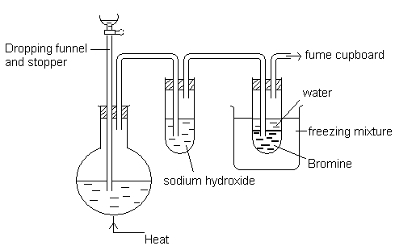  A mixture of concentrated H₂SO₄ and CH₃CH(CH₂CH₃)CH(OH)CH₃ heated in the flask to about 170 °C. A compound B, which is the major product of the reaction, was formed and B reacted with bromine in the second test tube to form C.
 | (a) | Give the structural formula of the compound B.  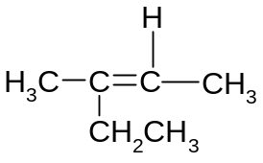 |  | [1]
 | (b) | Give the structural formula of compound C and give its IUPAC name.  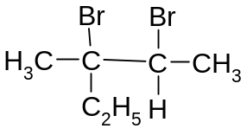  2,3-dibromo-3-methylpentane |  | [2]
 | (c) | Suggest a reason why aqueous sodium hydroxide was used in this procedure.  To remove traces of conc H₂SO₄ |  | [1]
 | (d) | The reaction mixture in the flask developed a light brown colour, which becomes black on heating to about 170 °C. Suggest a possible identity for the black colouration.  Carbon |  | [1]
 | (e) | State the type of reaction involved in the formation of C from B.  Addition |  | [1]

 | (f) | By structure, compound B is characterised by one functional group.
 |  | (i) | Identify the functional group.  Alkene
 |  | (ii) | A herbicide, mecoprop has the following structure  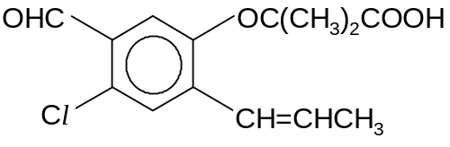  Other than the functional group identified in B-your answer in f(i), identify 2 other functional groups in the structure of mecoprop.  Aldehyde/Benzaldehyde and carboxylic acid
 |  | (iii) | State the type of stereoisomerism displayed by the structure of mecoprop. Draw the displayed formulae of the isomers. Label each isomer clearly.  Cis-trans isomerism / Geometric isomerism  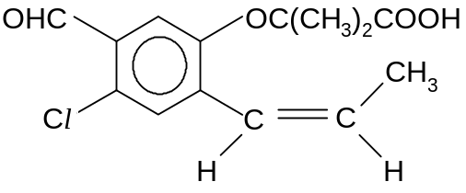Cis-isomer  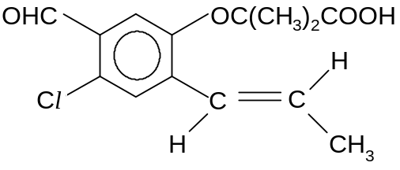Trans-isomer
 |  | (iv) | Describe two tests which can be performed on mecoprop separately to prove the presence of these two functional groups identified in f(ii).  You should include the reagents and conditions, observations andbalanced equation for each test.  Test 1: Aldehyde : 2,4-DNPH. Orange ppt  Test 2: Acid: Na₂CO₃, CO₂ effervescence
 |  | (v) | Draw the structure of the product formed when mecoprop reacts with
 |  | I | PCl₅
 |  | II | CH₃CH₂OH  For appreciable yield, II is carried out under a special condition. Briefly discuss this procedure.  [You may disregard the minor side-reaction involving other functional groups in mecoprop.]  Structures  I II  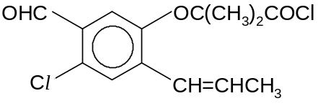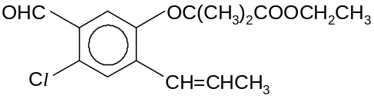  A small amount of conc H₂SO₄ is to be added as a catalyst for this esterification process between an alcohol and the acid in mecoprop.
 |  |  |  |  |  | [14]
 |  |  | [Total: 20]

